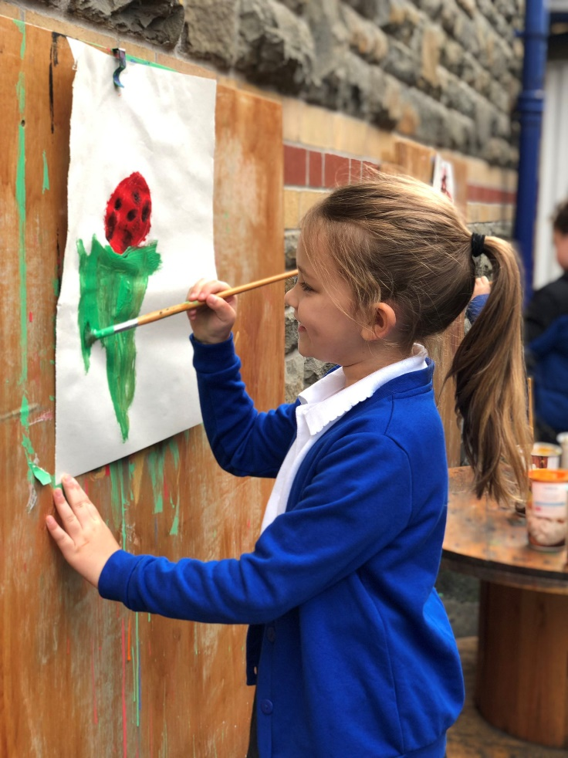

School Prospectus
2025-26
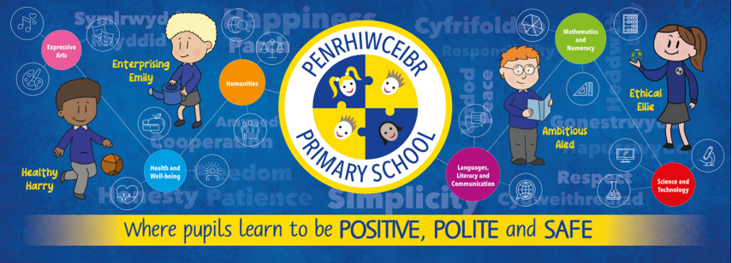

Contact details:

Penrhiwceibr Primary School
Church Street,
Penrhiwceiber
Mountain Ash
CF45 3YD

Tel: 01443 472247 Fax: 01443 473636
E Mail: admin@penrhiwceibrprimary@rctcbc.cymru
www.penrhiwceibrprimary.co.uk

Chair of Governors: Dr B John
Vice Chair of Governors: Cllr A Fox
Executive Headteacher: Mr N Vaughan (Seconded to Penywaun Primary)
Acting Headteacher: Mr G Phillips
Acting Deputy Headteacher: Mrs N Lewis

Follow us on twitter
@penrhiwceibr
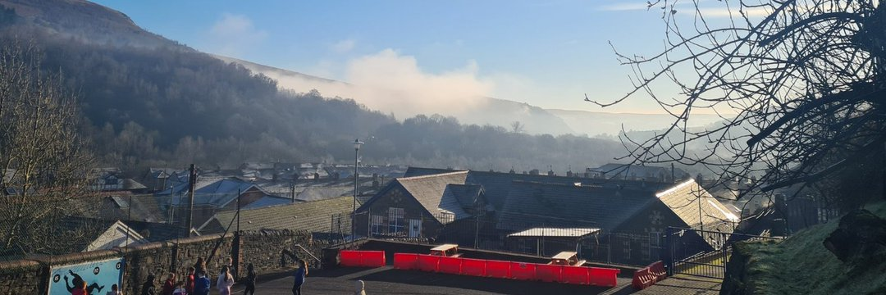
Penrhiwceibr Primary School is situated in the village of Penrhiwceibr a mile or two from the towns of Mountain Ash and Abercynon. It is positioned at the heart of a former mining community surrounded by beautiful rolling countryside.

Penrhiwceibr Primary School was formed in 2003 following the amalgamation of Penrhiwceibr Infants and Junior Schools –schools that had served the locality well for over 100 years.
The school itself is situated on 3 levels separated by playgrounds and although the external appearance remains unchanged, the curriculum, resources and expertise reflect the 21st Century.
Our school caters for children from 3 to 11 years of age and we also have a Flying Start facility offering fantastic early years learning to all children in the locality. Call Flying Start at School on 01443 476116 for FREE childcare for 2-3-year olds.
Children transfer to Secondary Education in September following their eleventh birthday. We are a ‘feeder’ school for Mountain Ash Comprehensive School although families with a church connection also consider St John the Baptist High School in Aberdare.
Parents whose children are starting at Penrhiwceibr Primary School will be required to complete School Admission Form, Medical Form and to sign a Home School Agreement, internet Form and a Consent Form for trip and photographs.

Headteacher Welcome

Dear Parents and Carers,
A very warm welcome to all our children, parents, carers, families, friends and members of our local community who play such an important part in the life of Penrhiwceibr Primary School.
At Penrhiwceibr, our whole school community is guided by our core values of being Positive, Polite and Safe. These values help make our school a caring, happy and harmonious place where everyone is valued and encouraged to do their best.
We are proud to share this school prospectus with you. We hope it gives you a clear picture of our school life — the learning experiences we offer, the values we promote, and the kind of education your child will enjoy and benefit from.
Penrhiwceibr Primary is a warm, welcoming school where everyone is kind, respectful and supportive of one another. We are proud of the positive relationships we build, creating an environment where learning is accessible, engaging and rewarding for all. I feel extremely privileged to be the Acting Headteacher of such a special school with such strong community spirit and commitment.
We have a dedicated and caring team of staff who work hard to provide our pupils with a wide range of opportunities and rich learning experiences, helping them to grow in confidence and achieve their potential.
Thank you for your continued interest and support. I look forward to getting to know you and working together to ensure every child at Penrhiwceibr Primary thrives and enjoys a happy, successful journey through school.
With kind regards,
Mr G Phillips
Acting Headteacher
Penrhiwceibr Primary School

Our Vision
At Penrhiwceibr Primary School we pride ourselves on holding a vision for our pupils that ensures that all pupils achieve the very best education. Our vision at Penrhiwceibr Primary School:
At Penrhiwceibr Primary, we are proud to be an inclusive, child-centred school at the heart of our South Wales community. We strive to nurture independent, confident and resilient learners who take pride in who they are and where they come from. We celebrate independence and encourage every child to reach their full potential. Through a rich, engaging and inspiring curriculum, we provide meaningful experiences that help our pupils flourish both in school and beyond. We promote a strong sense of belonging, an understanding of ‘Cynefin’, the wider world, and a lifelong love of learning — preparing our children to thrive as kind, capable and responsible global citizens.
Our vision is based on 4 core purposes, where pupils learn to become:


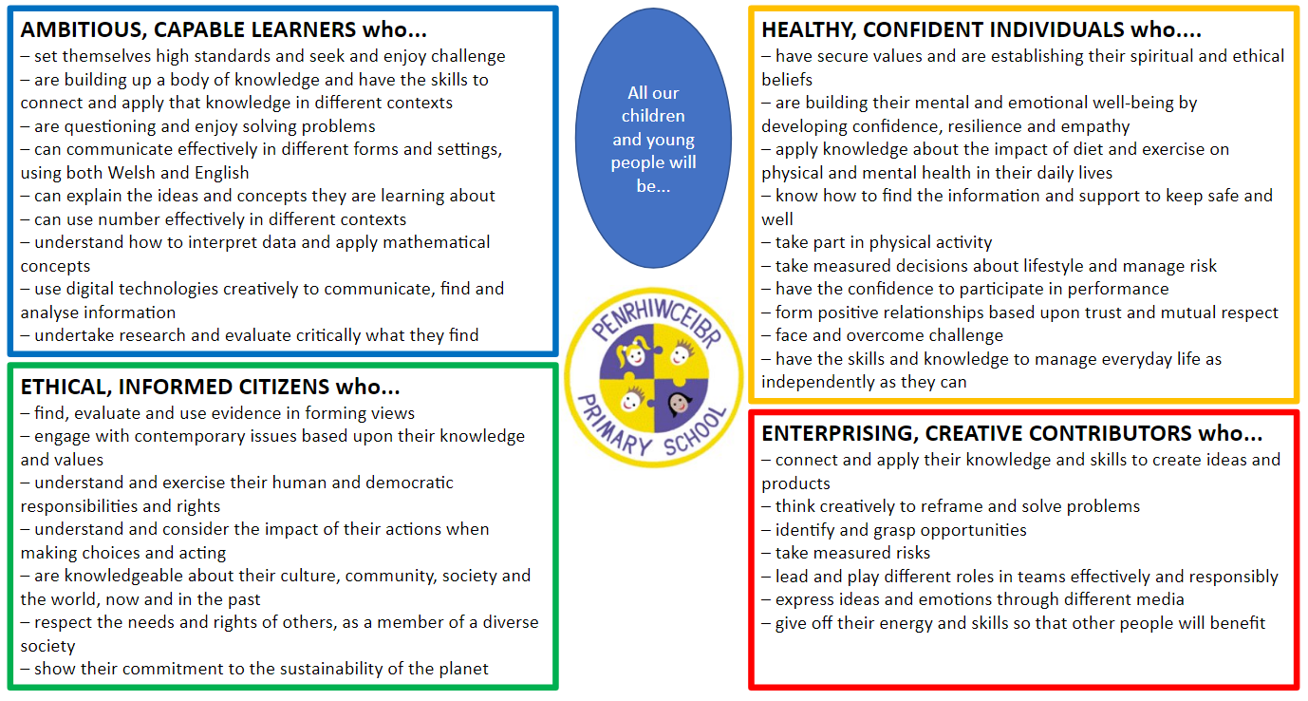

Values at Penrhiwceibr Primary School

Alongside the vision for our pupils, we hold a set of values that we aim to develop in them and our staff. Not only do we wish them to develop academically, but we believe that our role as a school is also to promote our pupils as good citizens in their Community; with high levels of well-being and self-esteem.

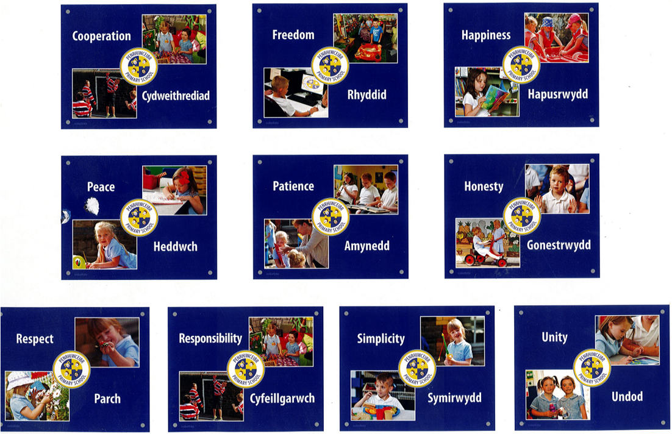

Staffing structure
Penrhiwceibr Primary School 2025-26
SLT
Acting Headteacher | Mr Gareth Vaughan
Acting Deputy Headteacher | Mrs Natalie Lewis
Foundation Leader | Mrs Rhian Welch
ALNCO | Mrs Natalie Lewis
Digital Technology Lead | Mrs Ceri Williams

Teachers
Dosbarth Acorn | Mrs Rhian Welch and Miss Sarah Evans
Dosbarth Beech | Ms Anika Hosford
Dosbarth Laurel | Mrs Gemma Thomas
Dosbarth Oak | Mrs Natalie Lewis and Mrs Ceri Williams

Support Staff
Foundation Phase
Dosbarth Acorn | Mrs Sandra Colwill, Mrs Sharon Bowen,  Mrs Bernadette Kelly, Dr B John
Dosbarth Beech | Mrs Paula Griffiths, Mrs Jackie Thompson
ELSA | Mrs Sharon Bowen
KS2
Dosbarth Laurel | Mrs Shelley Evans
Dosbarth Oak | Mrs Sarah Campbell
ELSA/PPA teacher | Mrs Sarah Meyler
Intervention Leader | Mrs Sarah Campbell

Family Engagement Officer | Mrs Bernadette Kelly
School Clerk | Mrs Beth Carroll
Caretaker/ Cleaner | Mr Paul Keating

Governing Body
Chairperson | Dr Barbara John
Vice-Chairperson | Cllr Adam Fox
LEA | Dr Barbara John
LEA | Cllr Adam Fox
LEA | Mr Gareth Thomas
Community | Mrs Joanne Neads
Community | Rev. Stuart Ghezzi
Community | *Vacancy*
Parent | Mrs Melanie Wilson
Parent | Miss Kori Davies
Parent | Mrs Stacey Parfitt
Parent | Mrs Paige Williamson
Teacher | Mr Gareth Phillips
Non-teacher | Mrs Bernadette Kelly
Headteacher (Acting) | Mr Gareth Phillips

The Governors of the school are responsible for the staffing, finance, premises, curriculum and future planning of the school. They work very closely with the headteacher in making decisions about the school. At Penrhiwceibr Primary School there are 15 governors: 4 are elected by the parents, 3 are local authority appointees, 3 Community based governors, 2 are elected from the staff of the school and the headteacher is also a governor. Election for Parent Governors occur every 4 years. There is currently one Community Governor vacancy.

Term Dates and Holidays

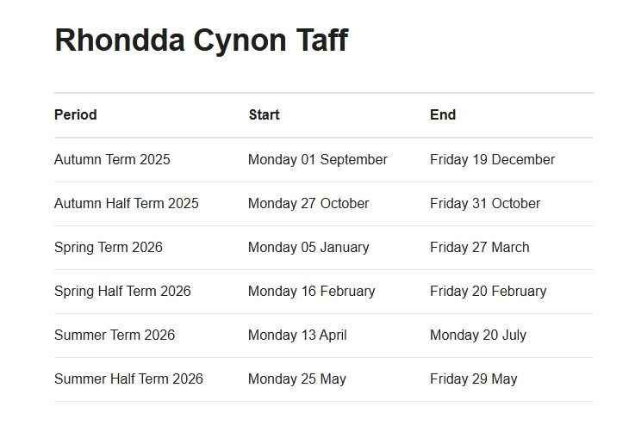
Mon 1st and 2nd Sept, Friday 24th October, 2025 and Monday 5th January and Monday 20th July 2026 will be designated INSET days for all LEA Maintained Schools. The remaining three INSET days to be taken will be at the discretion of each individual school following appropriate consultation with staff.
All schools will be closed on Monday 4th May 2026 for the May Day Bank Holiday.

School Organisation
There are at present 107 pupils on roll. We have 4 classes - 2 mainstream Foundation Phase classes and 2 Key Stage 2 classes. All of our classes are mixed year groups. Some pupils might spend two years with one teacher. This does not mean they stay at the same stage, only in the same room, as some classes have two even three age groups. The division depends on the number we have in each school year. The pupils are assigned a class on a variety of reasons, which include, age, ability, needs, friendships, family, maturity, etc.
Our classroom names start with the smallest pupils in Dosbarth Acorn with age groups climbing the tree to Dosbarth Oak and our oldest pupils.

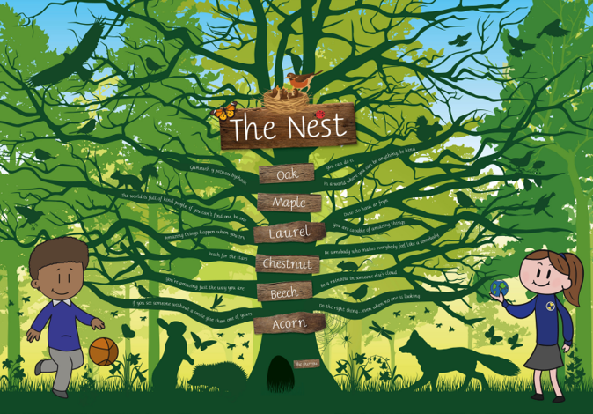

School Routines

School Day | 9:00am – 3.10pm |  | 9:00am – 3.20pm
 | Foundation Phase |  | KS2
 |  | Time |  | Time
Morning | Registration | 5mins | Registration | 5 mins
Session 1 | 9:05 – 10:15 | 1 hour 10 mins | 9:05 – 10:15 | 1 hour 10 mins
Collective Worship | 10:15 – 10.30 | 15 mins | 10:15 – 10.30 | 15 mins
BREAK | 10.30 – 10.50 | 20 mins | 10.30 – 10.50 | 20 mins
Session 2 | 10.50 – 12:00 | 1 hour 10 mins | 10.50 – 12.15 | 1 hour 25 mins
Lunch | 12:00 – 1:00 | I hour | 12:15 – 1:00 | 45 mins
Afternoon begins: | 1:00pm |  | 1:00pm
 |  | Time |  | Time
Afternoon | Registration | 5 mins | Registration | 5 mins
Session 3 | 1:05 – 2:05 | 1 hour | 1.00 – 2:00 | 1 hour
Break | TOILET/MILK | 10 mins | TOILET/Break | 10 mins
Session 4 | 2:15 – 3:10 | 55 mins | 2:10 – 3:20 | 1 hour 20 mins
Total teaching time per day = | 4 hours 15 mins |  | Total teaching time per day = | 4 hours 55 mins
Total teaching time per week = | 21 hours  15 mins |  | Total teaching time per week = | 24 hrs  35 mins
Total collective worship per week = | 75 mins |  | Total collective worship per week = | 75 mins

Attendance and Punctuality Parents should ensure that children arrive on time. Punctuality is important. Please assist your child in developing this good habit and ensure that they are in the school yard at 8.50am. The school cannot take responsibility for children who arrive at school earlier than 8.50am. Staff are on hand for a period of 10 minutes before and after school.
Punctuality and regular attendance at school are vital. Children who arrive after the register after 9.15am are deemed late therefore they will be recorded as late on the register. Please report every day of absence by telephone. The school is required by law to keep a note of absences for every pupil.
Absences fall into two categories: An authorised absence is recorded when the school has been informed of the pupil’s absence and the reason for absence complies with the list of reasons generally accepted by the Local Authority. An unauthorised absence is recorded when the school has not been informed of a pupil’s absence, or when the reason for absence does not comply with the list of reasons generally accepted by the Local Authority. A fine may be issued to a parent of a child who takes more than 10 days unauthorised absence from school within a term. The Attendance Welfare Officer will visit parents in cases where there are frequent absences. This applies to both authorised and unauthorised absence.
Late collection of children. Should unforeseen/exceptional circumstances prevent your child being met on time please try your best to telephone and alert us to the situation. In this event your child will be taken to the School Office at the Main Entrance where s/he will be supervised until your arrival. There are formal procedures where this time extends beyond a reasonable time regularly. Children who have to attend a medical, dental or hospital appointment should show the School Clerk the appointment card. Whenever possible these appointments should take place outside school hours. Family holidays taken during term time are authorised absences up to a period of 5 days per school year. Any additional holidays will be unauthorised.
Leaving school early. Occasionally parents request that their child/ren be dismissed from school during the school day. We are happy to co-operate with such requests. However, to avoid confusion and in the interests of safety requests should be in writing or by telephone. Requests relayed verbally by the children will be refused.

Breakfast Club School is open at 8:10am for Breakfast Club. Pupils are entitled to a fee breakfast. Attendance will not be permitted after 8:30 am. If you are interested in your child attending Breakfast Club on any day, please ask for a registration form from Mrs Carroll. Parents are advised that pupils not attending Breakfast Club should arrive between 8:50am and 8:55am.
Dinner arrangement and payment School meals are provided in our dining room. All dinner money is to be paid online. Please contact the school office for help to set up online payments or follow the link https://www.rctcbc.gov.uk/EN/Resident/SchoolsandLearning/Schoolcatering/Payyourschooldinnermoney.aspx
If you feel your income and family circumstance may entitle you to free meals, please do not hesitate to contact the school for the necessary application forms.
As of September 2023, the cost of School Meals is £13.50 per week or £2.70 per day.


Packed lunches Children may bring a packed lunch as an alternative to school meals. We do ask though that packed lunches conform with the schools Healthy Eating ethos.

Snacks Children may bring healthy snacks such as fruit for breaktimes.

Admissions The LA is the admitting authority for all children in Rhondda Cynon Taf (RCT) County Borough Council. Each child about to commence full time education will be offered a place in a school maintained by the LA. Applications for places in school must be done through RCT admissions department:
School Admissions Rhondda Cynon Taf County Borough Council Education and Lifelong Learning Ty Trevithick Abercynon Mountain Ash CF45 4UQ Email: schooladmissions@rctcbc.gov.uk Tel: 01443 744 232 Website: https://www.rctcbc.gov.uk/EN/Resident/SchoolsandLearning/Applyingforaschoolplace/Schoolad missionapplications.aspx

Induction Process

Every effort will be made to ensure child’s first experience of school life are positive and welcoming. Once your child reaches three years of age, we begin the admission process whereby children have a staggered start, gradually building up to a full day. All parents/carers will be invited to visit school, so that procedures and expectations can be explained and to provide an opportunity to view the classroom and its resources and also to discuss any issues which you feel are important with the class Teacher.
For children who enter at a later stage in their Primary Education e.g. after moving into the area, we will extend a warm and friendly welcome and make their entry into the school a pleasant experience.
You will be asked to complete a Pupil Information Pack to ensure we have contact details for your child. You will also be asked to complete separate forms regarding ICT safety, Local Trips and a Home School Agreement.

School Uniform

The co-operation of parents regarding wearing school uniform is very much appreciated, and this helps create an ethos of equality and teamwork throughout the School. There are local shops in Mountain Ash and Pontypridd who sell the items of clothing. They can also embroider the school logo onto clothes purchased at their shop.
Our school jumpers do not have to be embroidered with the school badge. We understand that cheaper and excellent value uniform can be bought at local supermarkets.
Additionally, we have a School Uniform Stop – which has a free supply of preloved uniform and shoes.
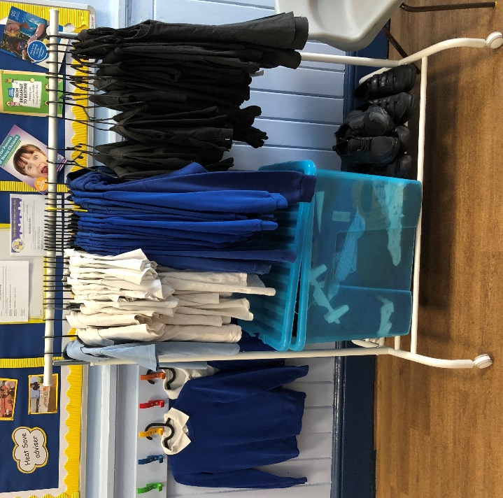
Boys
Black/grey trousers/joggers
White polo shirt
Royal blue sweatshirt/hoodie

Girls
Grey skirt/trousers/joggers
White blouse/polo shirt
Royal blue sweatshirt/hoodie/cardigan

For further information or an order form please contact the school.
In the interests of safety please unsure that your child wears suitable shoes for school (flat heeled, non-slip shoes).
ALL CLOTHING, FOOTWEAR, LUNCHBOXES MUST BE CLEARLY MARKED WITH YOUR CHILD’S NAME PLEASE.
No responsibility can be taken for personal property of the children at school.

Jewellery, apart from watches, should not be worn. Children with pierced ears should wear only studs. Apart from the risk of loss, there are many practical activities in which it constitutes a hazard to both wearer and other children.

Visiting Our School

Ordinarily, parents are welcome to visit at any time to discuss their child’s progress or any problems that have occurred. We normally have an open-door policy and every effort is usually made to speak with parents immediately. Due to the busy nature of school, there may be times when an appointment is necessary and your cooperation is much appreciated.

Reporting to Parents
Parents have the opportunity to attend Pupil Progress Meetings with the class teacher during the second half of the Autumn term. During the Spring Term parents will receive a Mid-Term written report summarising pupil progress and targets for development. A full written report regarding pupil’s progress is provided once a year at the end of the summer term and parents have the opportunity to discuss progress with teachers.
Parents are invited to our school to see your pupils’ assemblies, plays and concerts on a regular basis. Meetings for parents of pupils on our support programmes will occur 2 or 3 times a year. Messages are shared with parents via the My Child at School App. Throughout the year there will be various additional opportunities for parental engagement, parent sharing sessions and assemblies.

Keep up to date with school events on the School App, school website calendar, website and Twitter.

https://www.penrhiwceibrprimary.co.uk
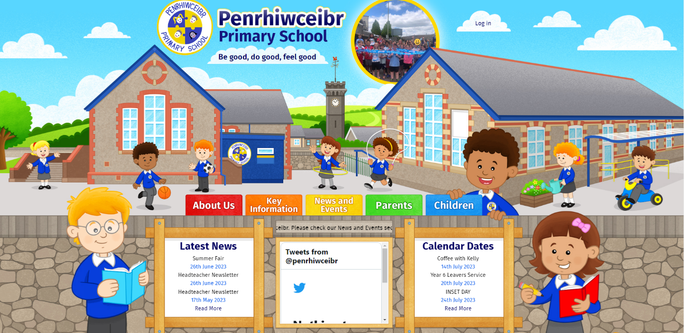
School to home communication
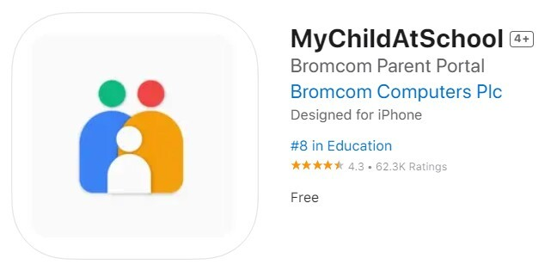
The My Child at School App is used to communicate important messages to our school community. The App also includes access to our school website, the school calendar events, school newsletters and more. Parents will need to download the App, please contact the school if you require assistance with this.

Teaching and Learning Non-Negotiables
At our school, we are committed to ensuring that every pupil experiences high-quality teaching and learning in line with the Curriculum for Wales. Our non-negotiables set clear expectations for all staff and reflect our shared belief that every child can achieve and thrive through engaging, inclusive, and purposeful learning.
1. Meeting Individual Needs
Teachers plan and deliver learning that is responsive to the needs of every pupil. Teaching is differentiated and adapted to provide appropriate challenge and support, based on each learner’s individual starting point. All pupils are encouraged to reach their potential as ambitious, capable learners.
2. Purposeful Planning and Progression
Teachers design well-sequenced learning journeys across all Areas of Learning and Experience (AoLEs). Each new topic, whether literacy, numeracy, or cross-curricular learning, builds on prior knowledge and leads pupils towards clearly defined next steps. Planning is underpinned by a variety of assessment for learning and assessment of learning strategies to ensure continuous progress.
3. Feedback and Reflection
Timely and constructive feedback is central to the learning process. Teachers provide immediate verbal feedback and written marking that guide pupils on how to improve. Pupils are given dedicated time to respond to feedback, reflect on their learning, and consolidate their understanding.
4. Varied and Engaging Learning Experiences
Learning is delivered through a balance of teacher-led sessions, supported group work with teaching assistants, and independent learning opportunities. Weekly challenges in numeracy, literacy, digital competence, and creativity promote independence, problem-solving, and the development of the four purposes.
5. Learning Environment
Classrooms and shared spaces are designed to stimulate curiosity and celebrate achievement. Displays support ongoing learning, showcase pupils’ work, and reinforce our school’s values and pedagogy. Enhanced provision and creative play opportunities inspire learners to be independent, resilient, and resourceful.
6. Assessment and Support
Assessment begins upon entry to Nursery and continues throughout the Early Years Foundation Phase and beyond. Progress is carefully tracked to ensure each pupil is achieving appropriate developmental milestones. From Year 3 onwards, pupils are assessed termly in reading, spelling, and numeracy. Any pupil requiring additional support receives timely, targeted intervention to help them succeed and reach their potential.

The Curriculum
In 2022 we will adopt and implement the new ‘Curriculum for Wales’. The curriculum has been reformed across Wales in order to raise standards, reduce the attainment gap, and prepare young people with the skills they need to live in today’s rapidly changing society.
‘Curriculum for Wales’ requires each school to develop its own bespoke curriculum, and over the last 2 years we have worked with fellow practitioners in our cluster, learners, parents, carers and the wider community to inform our curriculum’s development.
The aspiration of ‘Curriculum for Wales’ is to enable all learners to develop towards
achieving the four purposes of the curriculum. Our curriculum is everything a learner experiences in pursuit of the four purposes. It is not only what we teach, but how we teach and most importantly, why we teach it.
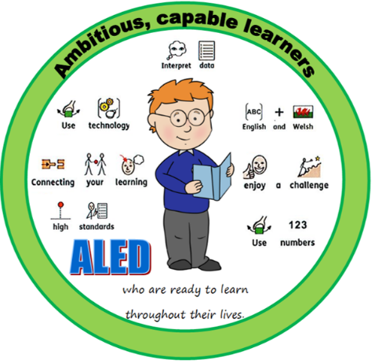


The four purposes are at the heart of our new curriculum. They are the starting point for all decisions on the content and experiences developed as part of the curriculum to support
our children and young people to become:
• Ambitious, capable learners ready to learn throughout their lives
• Enterprising, creative contributors, ready to play a full part in life and work
• Ethical, informed citizens of Wales and the world
• Healthy, confident individuals, ready to lead fulfilling lives as valued members of
society.



The new curriculum will include:
• 6 Areas of Learning and Experience from 3 to 16
• 3 Cross curriculum responsibilities: literacy, numeracy and digital competence
• Progression reference points at ages 5, 8, 11, 14 and 16
• Achievement outcomes which describe expected achievements at each progression
reference point

6 AoLE – Areas of Learning Experience
Expressive arts
This area incorporates art, dance, drama, film and digital media and music.
Health and well-being
This incorporates physical health and development, mental health and emotional and
social well-being.
Humanities (including RE which should remain compulsory to age 16)
This incorporates geography, history, religion, values and ethics, business studies and
social sciences.
Languages, literacy and communication
This incorporates Welsh, English and international languages as well as in literature.

Mathematics and numeracy
In the early years this will incorporate play (problem solving, exploring ideas, establishing
connections and collaborating). In later years it will focus on working both independently
and collaboratively.
Science and technology
This incorporates the sciences, computer science and design and technology.

Children will also learn about:
• Developmentally appropriate relationships and sexuality education
• human rights
• Diversity and respecting differences
• Experiences and skills for careers and the workplace
• Learning about local, national and international contexts

Welsh
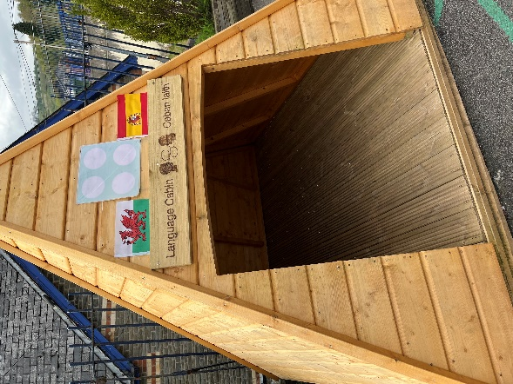
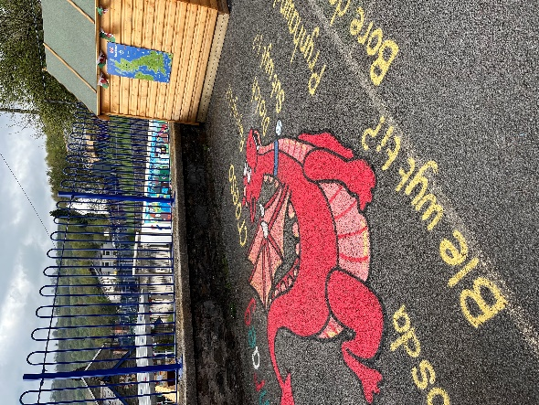
We encourage bilingualism at school and knowledge and understanding of curriculum Cymreig. Welsh as a second language is taught throughout the school. Children are encouraged to speak Welsh whenever possible. We also ensure the use of Curriculum Cymreig is developed wherever possible throughout all aspects of the curriculum.

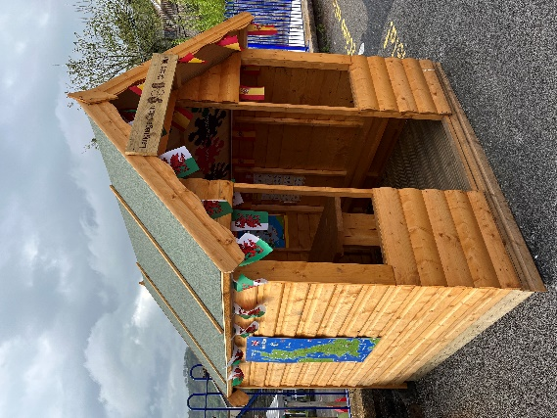
International Languages
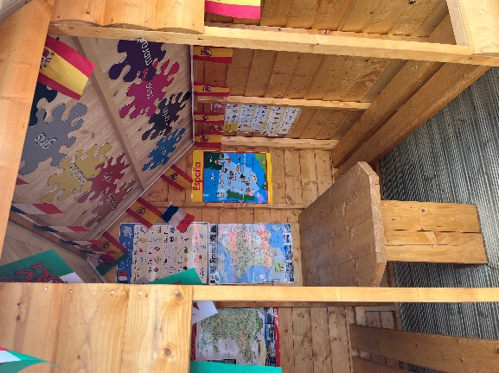
I addition to Welsh, pupils are also taught BSL (British Sign Language), Spanish and French (Year 6). We have international language zones set up on our playgrounds where pupils are encouraged to communicate in other languages.

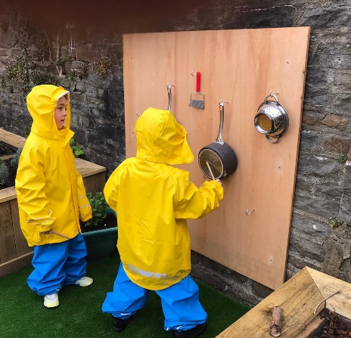

Outdoor Learning
All children in all year groups are encouraged to participate in outdoor learning every day. This is part of our health and well-being pedagogy and therefore we encourage all children to wear appropriate clothing such as a wearing a coat to school every day. Each class has an outdoor classroom and garden.

Religious Education and Collective Worship
Non-denominational Religious Education is provided for all children as part of the curriculum and is in accordance with the local agreed County Religious Education syllabus. Daily Acts of Collective Worship (Assembly) is an important part of the school day when we meet together as a community. It is a time when we place emphasis on the development of values and attitudes towards each other and the world around us. Assemblies are nondenominational and although they are of a broadly Christian nature due consideration is given to the multicultural society in which we live.

Additional Learning Needs
Children’s progress is constantly monitored and assessed and careful records are kept. Occasionally we find that a child does not make the progress we expect. If this were the case parents would be consulted and appropriate steps to support the child taken. An Individual Education/Development Plan may be made with individual targets, review dates and ideas to help parents to support their child at home. If targets continue not to be met, outside agencies such as Educational Psychologists, Speech and Language Therapists, Specialist Teachers or Behaviour Specialists may be called upon for extra support. After further consultation with parents the Local Authority (LA) may have to make a statutory assessment based on specialist advice. This describes all of the child’s needs and all the special help that should be provided. Parents will always be consulted and kept fully informed at every stage once we have identified that their child could benefit from some extra help. This could be for educational, personal or social needs. Our assessment procedures will identify children of very high academic ability and work will be planned to meet the learning requirements of these children. Outside agencies may be used to supplement school resources.

Sex and Relationship Education (SRE)
SRE is incorporated into the general school curriculum and is now a statutory duty for schools. It is always approached with sensitivity. Appropriate and responsible SRE is an important element in the work of schools in preparing pupils for adult life. Parents are the key figures in helping their children cope with the physical and emotional aspects of growing up and preparing them for the challenges and responsibilities which sexual maturity brings. The teaching offered by the school is complementary and supportive to the roles of parents. Teachers respond honestly to children’s questions, giving answers, which are appropriate to the children’s age, experience and understanding. We follow the Jigsaw scheme of work throughout the school.

Sporting Aims and Provision for Sport
We are proud of our sporting activities and achievements within school but recognise that many children are involved in many sporting activities outside school hours. Pupils are therefore encouraged to share with us their success outside of school and this is done throughout whole school collective worship sessions.
Swimming lessons at Abercynon Swimming Pool are available for Years 3, 4, 5 and 6 on a rota basis (organised by RCT Leisure Services). There is currently no charge for this and these
normally take place in the Spring term.
We offer a range of sporting clubs throughout the year alongside PE and Games during the school week. We expect ALL children to change for PE and Games sessions. Suitable clothing includes:
Shorts – no long ties or belts
T Shirts
Footwear – trainers (for outdoor activities) barefoot (for indoor / gymnastics activities)

Safeguarding Children
Penrhiwceibr Primary School is committed to ensuring the welfare and safety of all children in school. All Schools in Wales follow the All Wales Child Protection Procedures. The school will, in most circumstances, endeavour to discuss all concerns with parents about their children. There may be exceptional circumstances when the school will discuss concerns with Social Care and/or the Police without parental knowledge (in accordance with Local Safeguarding Board, Cwm Taf, Safeguarding Children Procedures). The school will, of course, always aim to maintain a positive relationship with all parents. The school’s Child Protection and Safeguarding policies are available on request. The school’s Safeguarding / Designated Child Protection officer is our Headteacher, Mr. Vaughan. In his absence the Deputy Designated Child Protection Officer Mr. Phillips will take on this role. In their absence Mrs. Welch or Miss Fraser, will take on the role. All of these nominated adults have received the minimum Level 3 Training through the Cwm Taf Safeguarding Board.

Children who are Looked After (CLA)
We are committed to the inclusion and high expectations of pupils who are identified as CLA. Class staff closely monitor their progress, achievement and attainment. The school’s designated CLA teacher is Mr. Vaughan. Mr. Vaughan has responsibility for maintaining all
Personal Education Plans (PEPs) and liaising with the assigned social worker and designated
family members.

Complaints
We acknowledge that from time-to-time parents/carers or pupils may wish to raise concern. Most can be settled quickly just by speaking to the relevant person in school, without the need to use a formal procedure.
We believe that all complainants have a right to be heard, understood and respected. But school staff and governors have the same right. We expect you to be polite and courteous.
We will not tolerate aggressive, abusive or unreasonable behaviour. We will not tolerate unreasonable demands or unreasonable persistence or vexatious complaining. We have a separate policy to manage situations where we find that someone’s actions are unacceptable.
The below table outlines the process the school will follow. In the first instance your concern should be discussed with the teacher or designated person before proceeding to the headteacher. NO complaint can proceed to the Governing Body or LA without following each Stage of the below procedure.
A copy of the school’s complaints procedure/policy can be found on the school website.



