School, Friends and Charity fund raising events 2025-26
Date | School Group/ Organisers | Event | Charity/Recipients | Money Total Raised
Autumn 1
1.10.26 | Super Ambassadors | Down Syndrome Awareness Month | 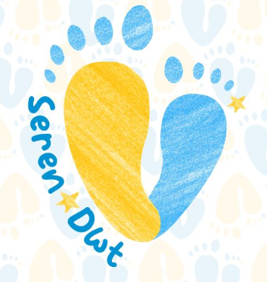 | £160
10.10.25 | Friends of Penrhiwceibr | Coffee Morning |  | £317
 | Eco Council | Harvest Food bank collection | 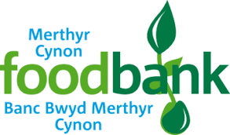 | Food Donations
 | Friends of Penrhiwceibr | Halloween Disco | 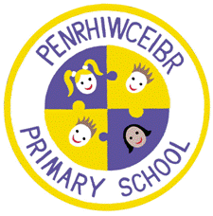 | £310
Autumn 2
 | Super Ambassadors | Poppy Appeal  Royal Legion | 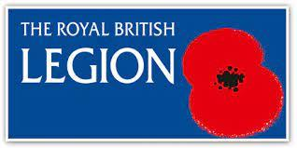
 | School Council | Children in Need | 
 | Friends of Penrhiwceibr | Christmas Fair | 
 | Super Ambassadors | Save the Children - Christmas Jumper Day |   
 | Friends of Penrhiwceibr | Christmas BINGO
Spring 1
 | School Council | Wear Red for Velindre | 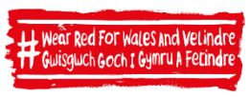
 | Friends of Penrhiwceibr | Valentine Disco
Spring 2
 | RCT Bronze Sports Ambassadors | Comic Relief, Red Nose Day | 
 | Friends of Penrhiwceibr | Easter BINGO
Summer Term
 | Friends of Penrhiwceibr | Summer Fair
 |  |  | Total

