Our School Vision
Published School Summary
At Penrhiwceibr Primary we to aim to develop;
- Children who seek opportunities to learn independently in a range of experiences. They develop the skills, confidence and self- esteem needed to achieve high aspirations.
- Children who work collaboratively and creatively to solve real life problems and make decisions. They understand their roles and the roles of others.
- Children appreciate their role within their local and global community. They show empathy and respect to those different from themselves and seek to broaden their understanding of the wider world.
- Happy, resilient and empathetic children who understand their bodies and minds. They learn from mistakes and value the achievement of others.

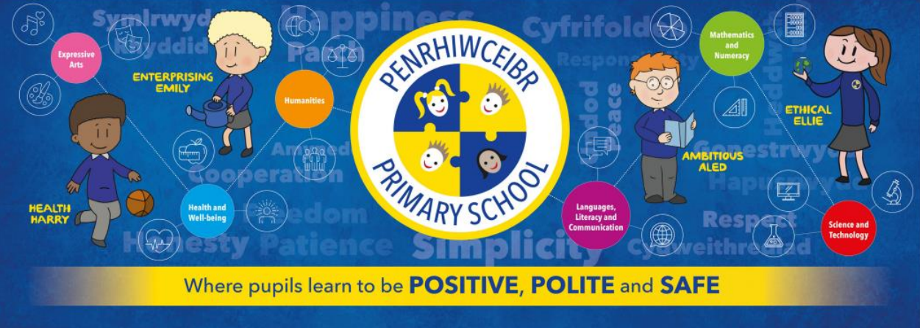
Our Curriculum
In 2022 we will adopt and implement the new ‘Curriculum for Wales’.
The curriculum has been reformed across Wales in order to raise standards, reduce the attainment gap, and prepare young people with the skills they need to live in today’s rapidly changing society.
‘Curriculum for Wales’ requires each school to develop its own bespoke curriculum, and over the last 2 years we have worked with fellow practitioners in our cluster, learners, parents, carers and the wider community to inform our curriculum’s development.
The aspiration of ‘Curriculum for Wales’ is to enable all learners to develop towards achieving the four purposes of the curriculum . Penrhiwceibr’s curriculum is everything a learner experiences in pursuit of the four purposes. It is not only what we teach, but how we teach and most importantly, why we teach it.

Meet our Four Purposes Characters


​ 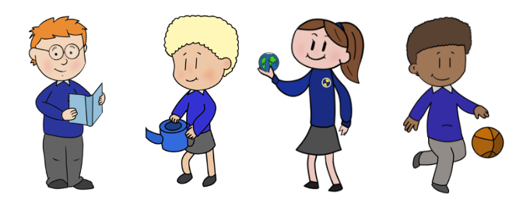
Ambitious Aled Enterprising Emily Ethical Ellie Healthy Harry

The four purposes are at the heart of our new curriculum. They are the starting point for all decisions on the content and experiences developed as part of the curriculum to support our children and young people to become:

- Ambitious, capable learners ready to learn throughout their lives
- Enterprising, creative contributors, ready to play a full part in life and work
- Ethical, informed citizens of Wales and the world
- Healthy, confident individuals, ready to lead fulfilling lives as valued members of society.

Our new curriculum will include:
- 6 Areas of Learning and Experience from 3 to 16
- 3 Cross curriculum responsibilities: literacy, numeracy and digital competence
- Progression reference points at ages 5, 8, 11, 14 and 16
- Achievement outcomes which describe expected achievements at each progression reference point.

Our curriculum will be organised into 6 Areas of Learning and Experience:
- Expressive Arts
This area incorporates art, dance, drama, film and digital media and music.
- Health and Well-being
This incorporates physical health and development, mental health and emotional and social well-being.
- Humanities (including RE which should remain compulsory to age 16)
This incorporates geography, history, religion, values and ethics, business studies and social sciences.
- Languages, Literacy and Communication
This incorporates Welsh, English and international languages as well as in literature.
- Mathematics and Numeracy
In the early years this will incorporate play (problem solving, exploring ideas, establishing connections and collaborating). In later years it will focus on working both independently and collaboratively.
- Science and Technology
This incorporates the sciences, computer science and design and technology.

Children will also learn about:
- Developmentally appropriate relationships and sexuality education
- Human rights
- Diversity and respecting differences
- Experiences and skills for careers and the workplace
- Learning about local, national and international contexts

Assessment and progression
Children will continue to be carefully assessed and this will focus on ensuring that all pupils understand where they are, and what they need to do next in order to progress.
Assessment will be part of your child’s learning every day. They’ll work with their teachers to celebrate the success in their work and understand how they can improve it further. They will have the opportunity to select the level of work that they feel is appropriate to them and teachers will challenge them to develop a growth mindset. This is important to help them understand where they are in their learning, to plan their next learning steps and to identify any additional support they may need or how they could be challenged further to achieve their full potential.

Evaluating and reviewing our approach to the new curriculum
Our approach to the new curriculum is evolving, and as such, will be continually revisited, reviewed and updated. Developing a bespoke curriculum to meet the needs of our pupils will be a school improvement priority 2022-2023. We will plan staff development opportunities, collaboration activities and regular feedback to parents, governors and the wider community on the progress we are making towards achieving the aims of the new curriculum.

July 2022

