Maths and Numeracy

At Penrhiwceibr Penrhiwceibr Primary school we understand that the Mathematics and Numeracy area of learning underpins many aspects of our daily lives, it is also essential for progress to be made in other areas of learning and experience. We strive to plan and deliver mathematical experiences that engage, excite and are as accessible for all pupils aiming to develop mathematical resilience in the pupils of Penrhiwceibr.
Daily Mathematical lessons take place across the school, with enhanced provision and missions giving pupils the opportunity to develop skills across all areas of learning and experiences. These learning opportunities and experiences are carefully planned by teachers and support staff through medium term and short term planning, utilising the resources and manipulatives within the classroom, digital technology and outdoor learning environments. Planning takes into consideration pupil voice and ensures that the Four Purposes are the starting point for developing pupils skills through Maths and Numeracy.
We believe that teachers need to be passionate when delivering Maths and Numeracy lessons, showing enthusiasm for the learning taking place. Through planning teachers ensure that the five independent proficiencies are in place to ensure progression in each stage of the mathematical learning process. Within each classroom a display, ‘Learning Wall’ can be found displaying the current skills being taught. ‘Stations’ will also be found in each classroom which allow learners to further develop skills and transfer them into other areas of learning.

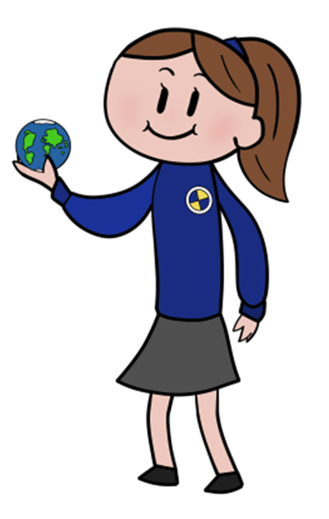

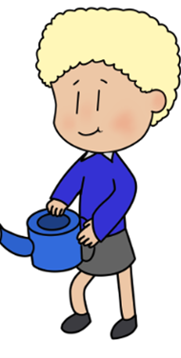


Statements of What Matters:  - The number system is used to represent and compare relationships between numbers and quantities.  - Algebra uses symbol systems to express the structure of mathematical relationships.  - Geometry focuses on relationships involving shape, space and position and measurement focuses on quantifying phenomena in the physical world.  - Statistics represent data, probability models chance, and both support informed inferences and decisions. | Key Links with other Areas:  - Science and Technology  - Humanities  - Health and well-being  - Expressive Arts  - Literacy, Language and Communication.  Cross Cutting themes: | Assessment to support Learner Progression:  - Learners are at the heart of assessment  - Assessment is an ongoing process  - There is a consistent understanding of progression  - A wide range of assessment approaches are used with immediate verbal feedback given as often as possible  - Self and peer assessment opportunities are planned for  - Parents/Guardians are informed on pupils progression
Descriptions of Learning:  - Progression step 1  - Progression step 2  - Progression step 3  - Progression step 4  For all the Statements of What Matters | Specific Consideration for LLC:  - opportunities to explore mathematically rich environments both indoors and outdoors.  - The structure and sequence of mathematics and numeracy topics should be informed by the hierarchical and connected nature of mathematical concepts, in order to ensure foundations are built upon and experiences are connected.  - Learners need to become increasingly fluent in their use of number, through a broad range of experiences  - Introducing a reasoning and problem-solving approach to all mathematics and numeracy experiences, the development of the four purposes and positive dispositions will be supported. | Cross Curricular skills:  - Literacy  - Numeracy  - Digital Competence  Integral Skills:  - Creativity and innovation  - Critical thinking and problem solving  - Personal effectiveness  - Planning and Organising

