Science & Technology

At Penrhiwceiber Primary school our aim is to promote interest, enjoyment , creativity and lifelong learning through real life, motivating and first hands on experiences. Teachers promote a positive attitude to Science and Technology within their classrooms by ensuring investigation stations are set up in their classrooms for pupils to explore independently during missions and enhanced provision. Such experiences are effectively planned for by class teachers utilising appropriate resources to their fullest. Teachers' planning is informed to some degree by pupils' voice, which gives pupils ownership and they feel connected to their learning.

We give all of our pupils the opportunity to explore and experience the world around them through inquiry based learning. Teachers plan for both indoor and outdoor learning experiences to ensure pupils are gaining meaningful and purposeful experiences across the curriculum. We have transformed our outdoor areas at Penrhiwceiber where pupils transfer their skills learnt in the classroom into the outdoor areas. This helps build learners' understanding of different environmental issues and show care, respect and concern for all living things and the environment we live in.

We believe it is also important to involve external professionals to provide authentic learning experiences. We have previously collaborated with a range of Science and Technology experts to broaden experiences and to deepen pupils' understanding.

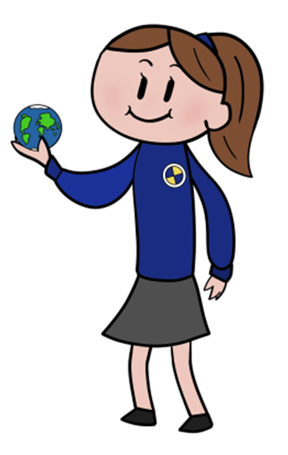

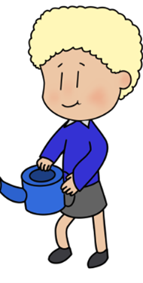


Statements of what matters:  - Being curious and searching for answers is essential to understanding and predicting phomema.  - Design thinking and engineering offer technical and creative ways to meet society’s needs and wants.  - The world around us is full of living things that depend on each other for survival.  - Matter and the way it behaves defines our universe and shapes our lives.  - Forces and energy provide a foundation for understanding our universe.  - Computation is the foundation of our digital world. | Key links with other areas:  - Health and wellbeing  - Maths and Numeracy  - Humanities.  - Literacy, Language and communication  - Expressive Arts.  Cross cutting themes:  - Careers and work related experiences in this area.  - Relationship and sexuality education. | Assessment to support learner: progression.  - Assessment is an ongoing process  - Verbal and written feedback given to pupils.  - Parents are informed of pupils' progression.
Descriptions of learning:  - Progression step 1  - Progression step 2  - Progression step 3 | Specific consideration for S&T:  - Pupils to be given the opportunity to have a breadth of learning.  - Exploration and experiences of the world through inquiry based learning. Indoor and outdoor learning.  - Develop fine and gross motor skills through a range of learning activities.  - Use a range of digital technologies across the curriculum. | Cross curricular skills:  - Literacy  - Numeracy  - Digital competence.  Integral skills:  - Creativity and innovation  - Critical thinking and problem solving.  - Personal effectiveness  - Planning and organisation.

