Expressive Arts

At Penrhiwceiber primary school we aim to engage, motivate and encourage learners to develop their creative, artistic and performance skills to the full. The Expressive Arts Area of Learning and Experience (Area) spans five disciplines: art, dance, drama, film and digital media and music. Although each discipline has its own discrete body of knowledge and body of skills, it is recognised that together they share the creative process.
At Penrhiwceiber, expressive arts is accessible to all learners and, through this inclusive approach, expands the horizons of every learner. Experiencing expressive arts can engage learners physically, socially and emotionally, nurturing their well-being, self-esteem and resilience. This can help them become healthy, confident individuals, ready to lead fulfilling lives as valued members of society. We encourage our children to express themselves in a way that is unique to them individually, to appreciate the creative work of other people, but also their own creative talents, artistic skills and performance skills.
We provide the children with a variety of experiences and opportunities such as visits to theatres and galleries and bringing the expertise of external practitioners into the classroom. Many of our after school clubs also provide creative opportunities for our children.
We want our learners to make progress as they increasingly evaluate and create more and more sophisticated creative work independently and with increased collaboration with others. They gain greater confidence by being able to explore, experience, interpret, create and respond through the expressive arts’ disciplines within a safe environment. We want our learners to transfer existing skills and knowledge into new contexts within this area and across other areas.

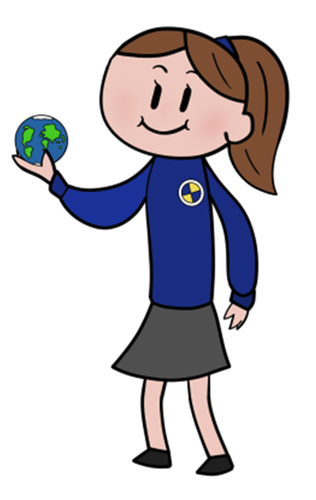

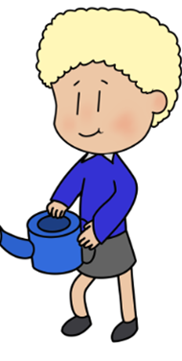
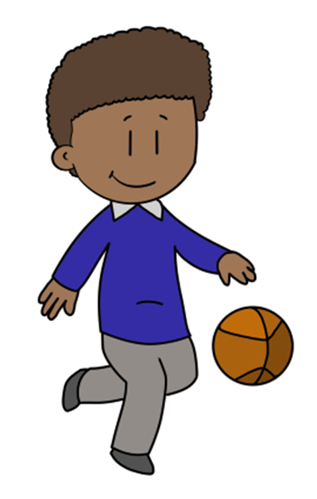

Statements of what matters:  Exploring the expressive arts is essential to developing artistic skills and knowledge and it enables learners to become curious and creative individuals.  Responding and reflecting, both as artist and audience, is a fundamental part of learning in the expressive arts  Creating combines skills and knowledge, drawing on the senses, inspiration and imagination. | Key links with other areas:  - Health and wellbeing  - Maths and Numeracy  - Humanities.  - Literacy, Language and communication | Assessment to support learners:  progression.  - Learners are at the heart of assessment  - Assessment is an ongoing process  - There is a consistent understanding of progression  - A wide range of assessment approaches are used with immediate verbal feedback given as often as possible  - Self and peer assessment opportunities are planned for  - Parents/Guardians are informed on pupils progression
Cross cutting themes:  Local, national and international contexts in this Area  Careers and work-related experiences in this Area  Human rights education and diversity in this Area  Relationships and sexuality education in this Area | Descriptions of learning:  - Progression step 1  - Progression step 2  - Progression step 3 | Specific consideration for E&A  - equitable opportunities to include the five disciplines of art, dance, drama, film and digital media and music  - progression along the continuum – complexity, control, depth and independence  - experience, knowledge and skills inherent to and across each discipline  - opportunities to work independently and collaboratively  - a range of stimuli, techniques, materials and resources, tools and technologies  - styles, genres and creative texts across all disciplines and spanning people, places, cultures and time  - discipline-specific vocabulary and skills  - experience of actual and virtual venues, and local, national and international arts events and festivals  - critical appreciation and response  - input from creative professionals and industry experience  - access to local, national and international contexts  - access to practical and theoretical exploration  - opportunities for learners to take on a range of roles and responsibilities within the creative process.

