Health and Wellbeing

At Penrhiwceibr Primary School, we believe that Health and Wellbeing of all our pupils, staff and parents is paramount to our philosophy and ethos ‘be good, do good, feel good’. We promote, develop, equip and prepare healthy learners for life. As a school we are committed to making it our mission to promote resilience, positive wellbeing and mental health for all our pupils and staff. We always put our pupils first in our approach to learning and strive to meet all our pupils’ individual needs.
The four core purposes underpin our approach leading to our pupils healthy, confident individuals who are resilient and empathic towards others.
Health and Wellbeing in Penrhiwceibr Primary School consists of yearly sports days, regular PE sessions and outdoor learning opportunities. We celebrate achievements every Friday and give out star of the week and golden pen certificates. We encourage outside activities and praise pupils for keeping active. We organise the local fire service, school nurse, design to smile and the police service to come into school to discuss relevant information with the different age groups. We make sure we plan and teach the importance of anti-bullying and E-safety. We have ELSA groups that take place in our designated calm areas in school - The Nest and The Burrow. At Penrhiwceibr Primary we offer a range of after school clubs that are tailored to everyone’s individual needs. These include fitness, team building and arts and craft. We encourage healthy eating and promote healthy snacks and water or squash in school.
We feel it is important that our pupils use self-reflection to support self-awareness, developing their understanding of who they are as an individual and who they aspire to be.

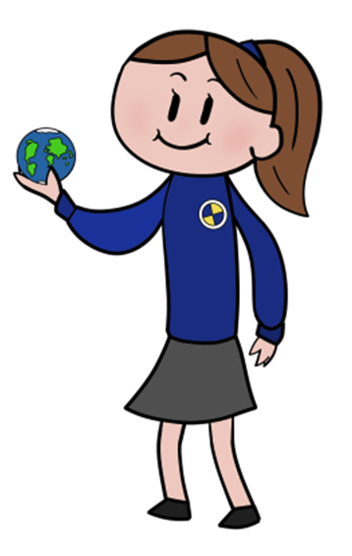
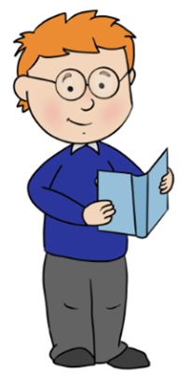
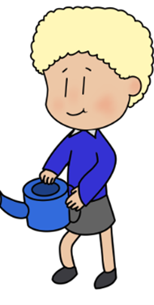
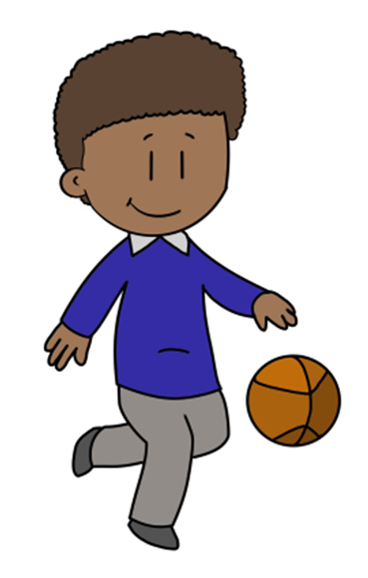

Statements of what matters;  - To help learners to understand the factors that affect physical health and well-being.  - To promote healthy behaviours such as physical activity, a balanced diet, sleep and personal care and hygiene  - To have an understanding of health-harming behaviours.  - For learners to have an awareness of their own feelings and emotions and to develop and empathy towards others.  - For learners to have an awareness of social influences on their lives and acceptable behaviours. | Key links with other areas:  - Expressive Arts  - Maths and Numeracy  - Humanities.  - Literacy, Language and communication | Assessment to support learners:  progression.  - Assessment is an ongoing process  - A wide range of assessment approaches are used with learners given verbal feedback as often as possible and are encouraged to self and peer assess.  - Parents/Guardians are informed on pupils progression
Cross cutting themes  - Physical Education  - Literacy  - Numeracy  - PSE through Jigsaw  - Expressive Arts | Descriptions of learning  - Progression step 1  - Progression step 2  - Progression step 3 | Specific consideration for H&W  - To develop physical health and wellbeing as life long benefits  - To develop fine and gross motor skills  - To make connections between diet and physical health and wellbeing  - To have an awareness of how our mental health is affected by our experiences.  - To appreciate what healthy relationships look like and when something is wrong.

