Languages, Literacy and Communication

At Penrhiwceibr we understand that the Languages, Literacy and Communication Area of Learning and Experience addresses fundamental aspects of human communication. We intend to ignite learners’ curiosity and enthusiasm and provide them with a firm foundation for a lifelong interest in the languages of Wales and the languages of the world. Daily Literacy lessons take place throughout the school, with enhanced provision and missions giving pupils independent and scaffolded opportunities to develop these skills across all areas of learning and experience. These experiences are carefully planned by teachers, through medium-term and short-term planning, utilising resources available inside the classroom, digital technology and outdoor learning opportunities where possible. Planning takes into consideration pupil voice and ensures the Four Purposes are the starting point for developing pupils’ skills through languages, literacy and communication.
Daily Guided Reading sessions strive to build confident readers who can confidently analyse texts for understanding. Literature expands horizons, we intend to ignite a spark where children read for enjoyment and pleasure. We aim to provide the building blocks for purposeful rich extended writing opportunities in a range of forms and genres, and to expand pupils' use of vocabulary through well planned opportunities for pupils to express themselves in a wide variety of forms and through multilingual experiences.
We believe the delivery of languages, literacy and communication lessons must be inspirational, where teachers have an enthusiasm for learning taking place. Teachers utilise creative teaching techniques and stories to hook pupils’ interest, and inform the learning journey. Displays and ‘Learning Walls’ support the current genre, with ‘stations’ utilised well in classrooms to further underpin learning. Teachers use the mandatory Statements of What Matters to explore the key ideas and principles of Literacy, Language and Communication, this is further supported by the descriptions of learning which guides progression in the development of pupils' learning. All of these Welsh Government documents support the planning and progression in this Area.
Teacher assessment is key to pupil progression, formative and summative assessment supports the development of skills. Teacher assessment informs future planning, immediate feedback is given as often as possible, and written feedback provides pupils with opportunities to celebrate their success. As well as the teachers, we aim for our pupils to be reflective practitioners, we provide them with opportunities to return to and improve their literacy skills, and self/peer-assessment plays a key role in identifying their strengths and areas for improvement.
We believe that the cross curricular skills promoted in languages, literacy and communication will allow pupils to express themselves effectively, to be open to other people’s points of view and to develop positive relationships. It will also prepare our pupils to become healthy, confident individuals, ready to lead fulfilling lives as valued members of society.
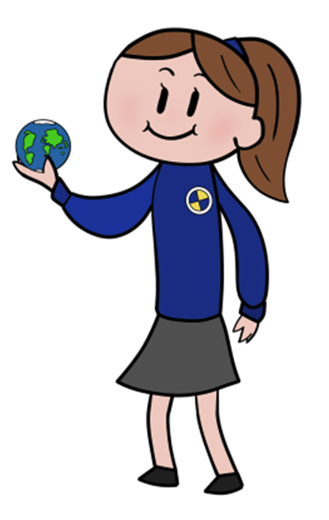
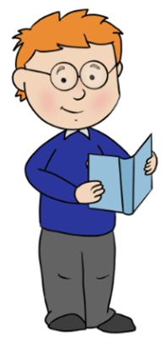
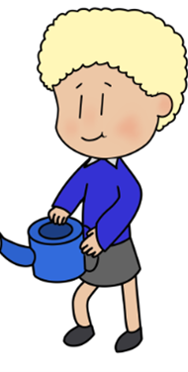


Statements of What Matters:  - Languages Connect Us  - Understanding language is key to understanding the world around us  - Expressing ourselves through language is key to communication  - Literature fires imagination and inspires creativity | Key Links with other Areas:  - Expressive Arts  - Health and Wellbeing  - Humanities  - Maths and Numeracy  - Science and Technology  Cross Cutting themes:  - Local, national and international contexts in this Area  - Careers and work-related experiences  - Human rights education and diversity  - Relationships and sexuality education | Assessment to support Learner Progression:  - Learners are at the heart of assessment  - Assessment is an ongoing process  - There is a consistent understanding of progression  - A wide range of assessment approaches are used with immediate verbal feedback given as often as possible  - Self and peer assessment opportunities are planned for  - Parents/Guardians are informed on pupils progression
Descriptions of Learning:  - Progression step 1  - Progression step 2  - Progression step 3  - Progression step 4  For all the Statements of What Matters | Specific Consideration for LLC:  - Four statements of What Matters in this area refer to Welsh, English and international languages  - In addition to Welsh and English, all learners should have the opportunity to learn at least one international language at school.  - Learners should experience a wealth of literature which provides opportunities to realise the four purposes  - Developing good listening and speaking skills is therefore vital to success in learning to read  - Increased knowledge of language can unlock the stories and histories of places such as Cymru | Cross Curricular skills:  - Literacy  - Numeracy  - Digital Competence  Integral Skills:  - Creativity and innovation  - Critical thinking and problem-solving  - Personal effectiveness  - Planning and organising

